Serverless Feedback Logger using AWS (S3, Lambda & CloudWatch)

Scenario:
Many organizations and applications require user feedback to improve their services. Collecting this feedback manually can be time-consuming and difficult to scale. Therefore, a cloud-based automated feedback collection system is essential. The goal is to design a serverless feedback collection system using AWS that allows users to submit feedback (as .txt or .json files), automatically process it through AWS Lambda, and log the responses using CloudWatch — ensuring cost-efficiency, automation, and scalability.

Problem Statement:
Collecting and processing user feedback in real-time without automation often requires complex server setups, manual monitoring, and database management. The challenge is to design a lightweight, serverless system that automatically stores and processes feedback files while maintaining visibility into operations, all without dedicated infrastructure.
Design an AWS-based serverless architecture to collect, process, and log feedback from users in real-time using Amazon S3, AWS Lambda, and Amazon CloudWatch.

Objectives:
- Enable users to upload feedback files (.txt or .json) seamlessly.
- Automate feedback processing using a serverless architecture.
- Monitor system performance and log feedback details with CloudWatch.
- Ensure a secure, low-maintenance, and cost-efficient solution.
- Build a fully serverless and easy-to-maintain feedback system.
- Outcomes:
- User feedback files are securely stored in Amazon S3.
- Each file upload triggers a Lambda function to process and log content.
- CloudWatch captures logs for monitoring and troubleshooting.
- The system is fully automated, serverless, and scalable with minimal costs.
- Proposed AWS Components:
- AWS Service- Role in the Project
- Amazon S3- Stores user-submitted feedback files ( .txt , .json ).
- AWS Lambda- Processes new files by reading and logging their content.
- Amazon CloudWatch- Monitors Lambda executions and stores feedback logs.
- AWS IAM- Grants permissions for Lambda to access S3 and CloudWatch.

Flow chart based upon Proposed AWS Components
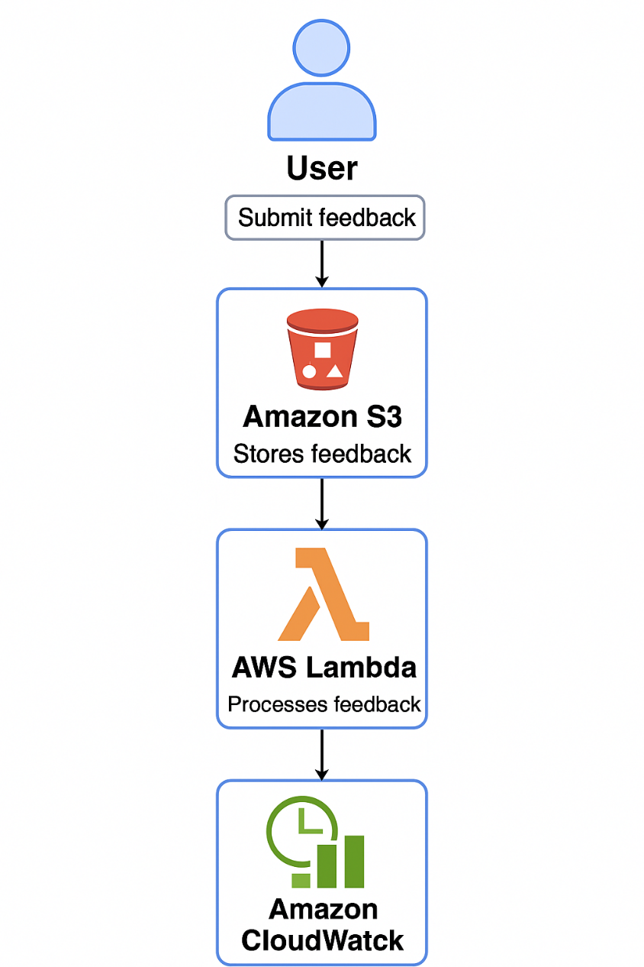

6.Solution:
Implementation :
Step 1: Create an S3 Bucket
Navigate to AWS Console > S3.
Click Create bucket and name it (e.g., feedback-collection-system).
Keep default settings (private, versioning enabled).
Optionally, create a folder named uploads/ for organization.
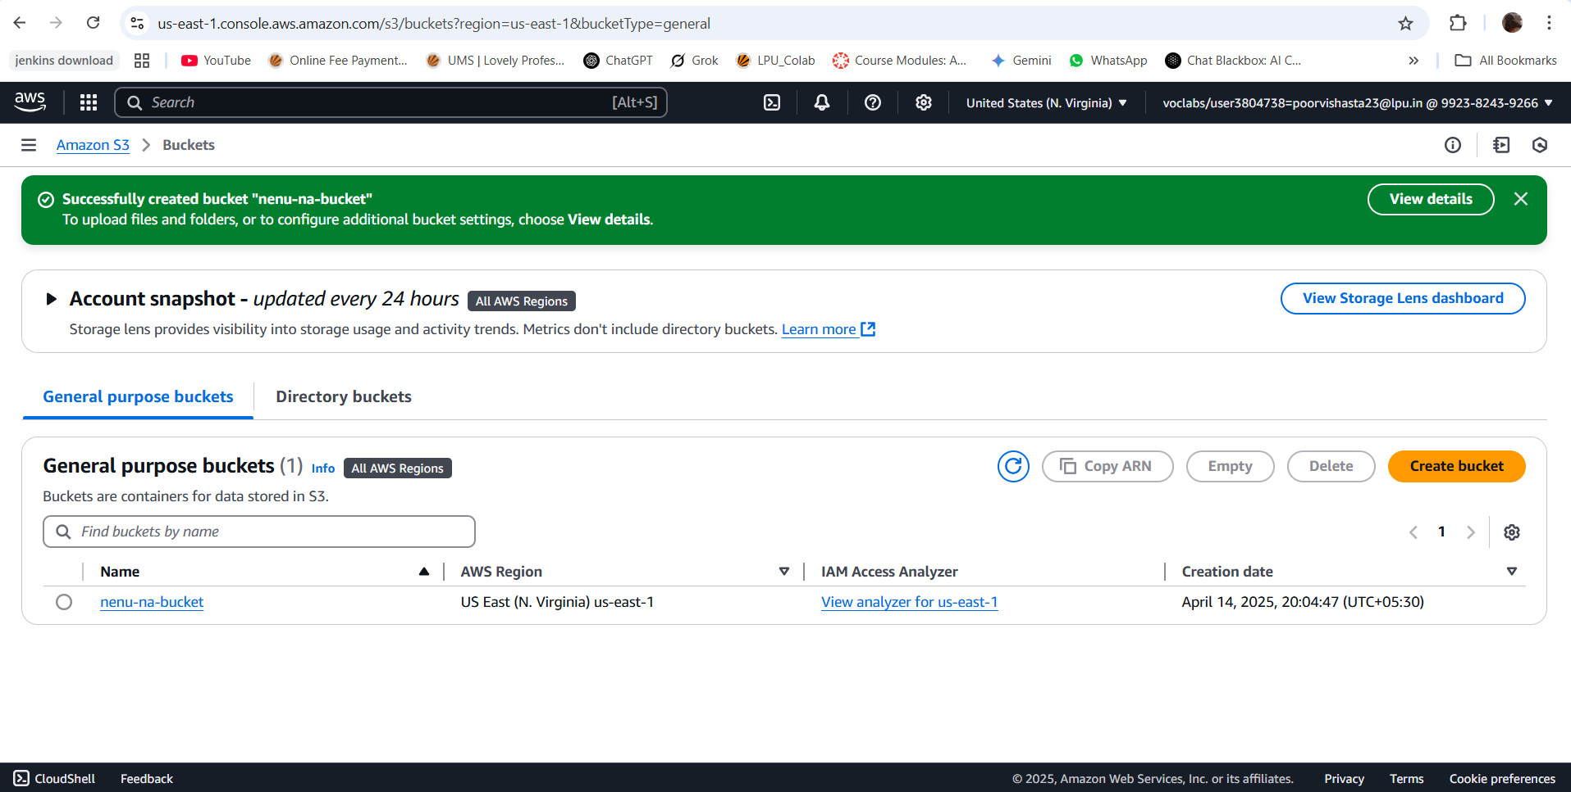
Step 2: Set Up a Lambda Function
Go to AWS Console > Lambda > Create function.
Name: feedbackserviceL
Runtime: Python 3.12.
Create a new IAM role with basic Lambda permissions.
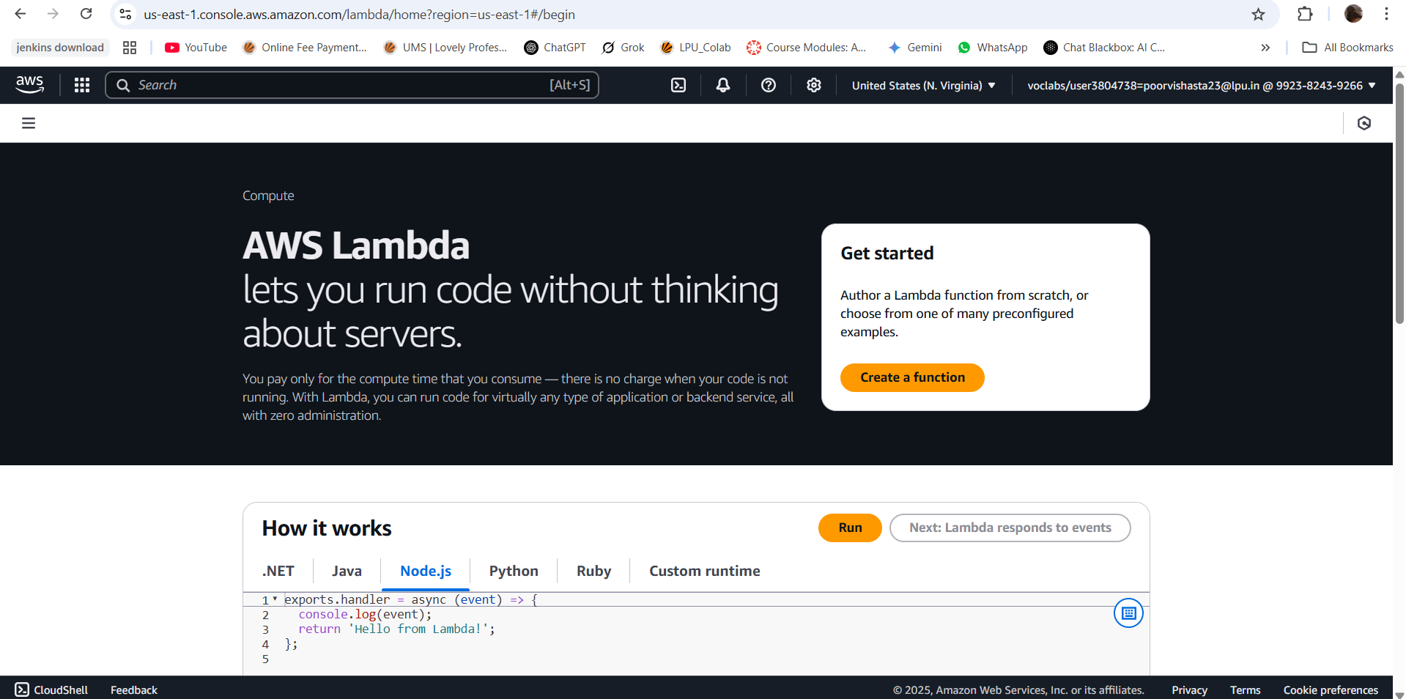

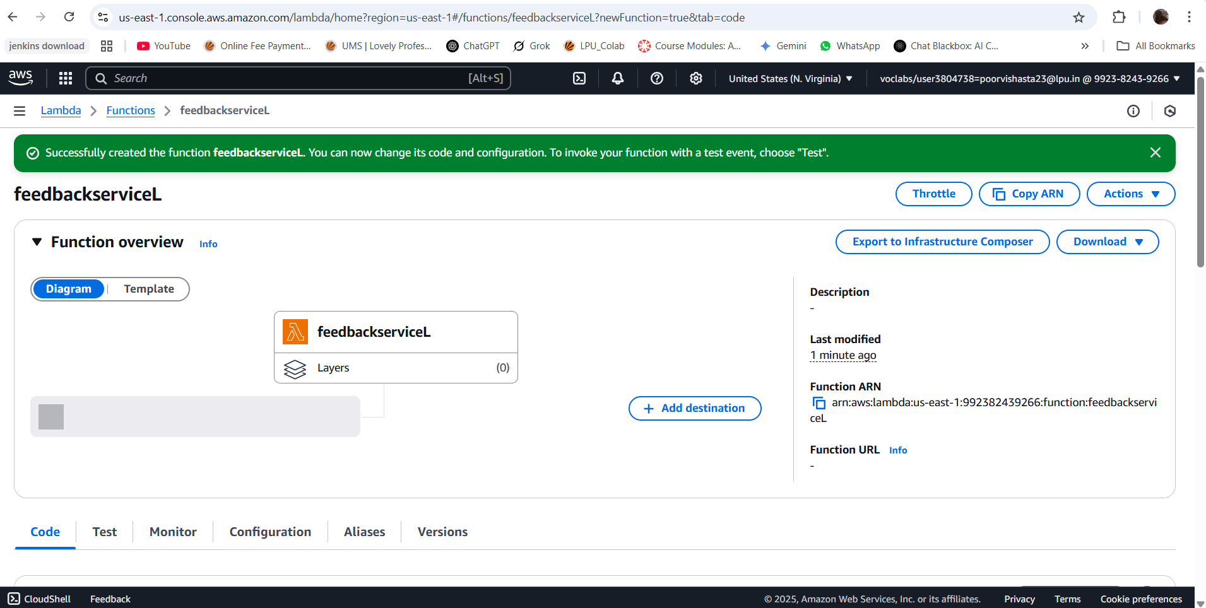
Add an S3 trigger:
Bucket: nenu-na-bucket
Event type: All object create events.
Prefix: uploads/ (optional).
Suffix: .json or .txt.
Code:
import json
import boto3
def lambda_handler(event, context):
s3 = boto3.client('s3')
bucket = event['Records'][0]['s3']['bucket']['name']
key = event['Records'][0]['s3']['object']['key']

response = s3.get_object(Bucket=bucket, Key=key)
content = response['Body'].read().decode('utf-8')

print(f"Feedback from {key}: {content}")

return {
'statusCode': 200,
'body': json.dumps('Feedback processed successfully')
}

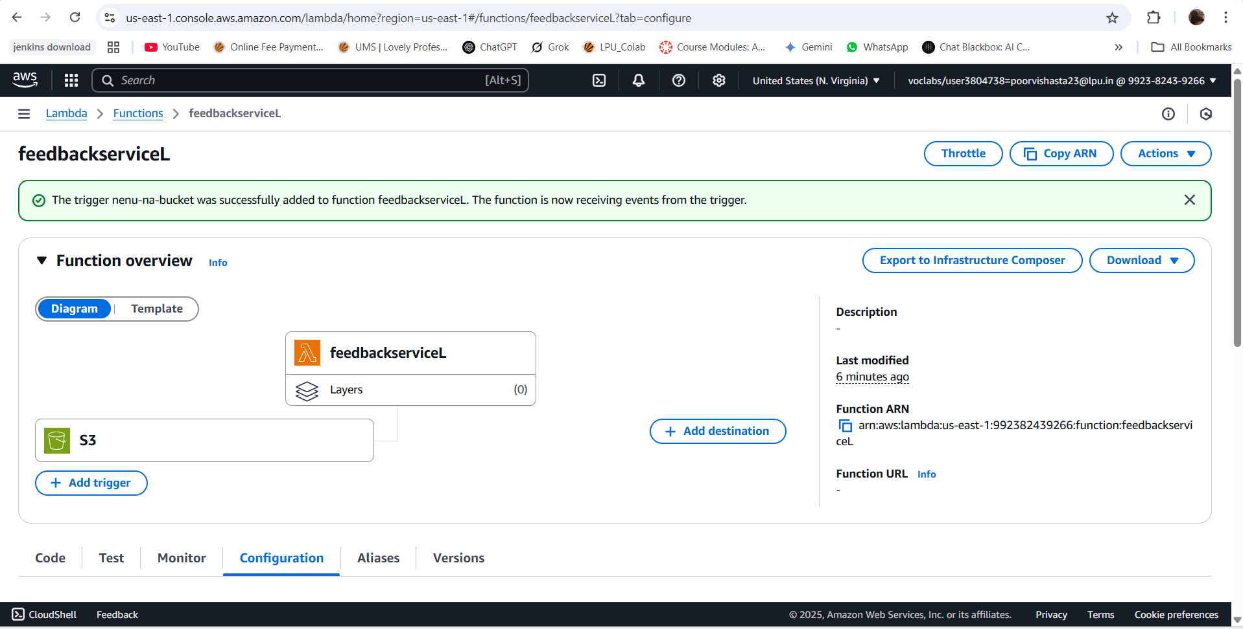
Step 3: Configure IAM Permissions
Go to AWS Console > IAM.
Update the Lambda role to include:
AmazonS3ReadOnlyAccess for accessing the S3 bucket.
CloudWatchLogsFullAccess for logging.

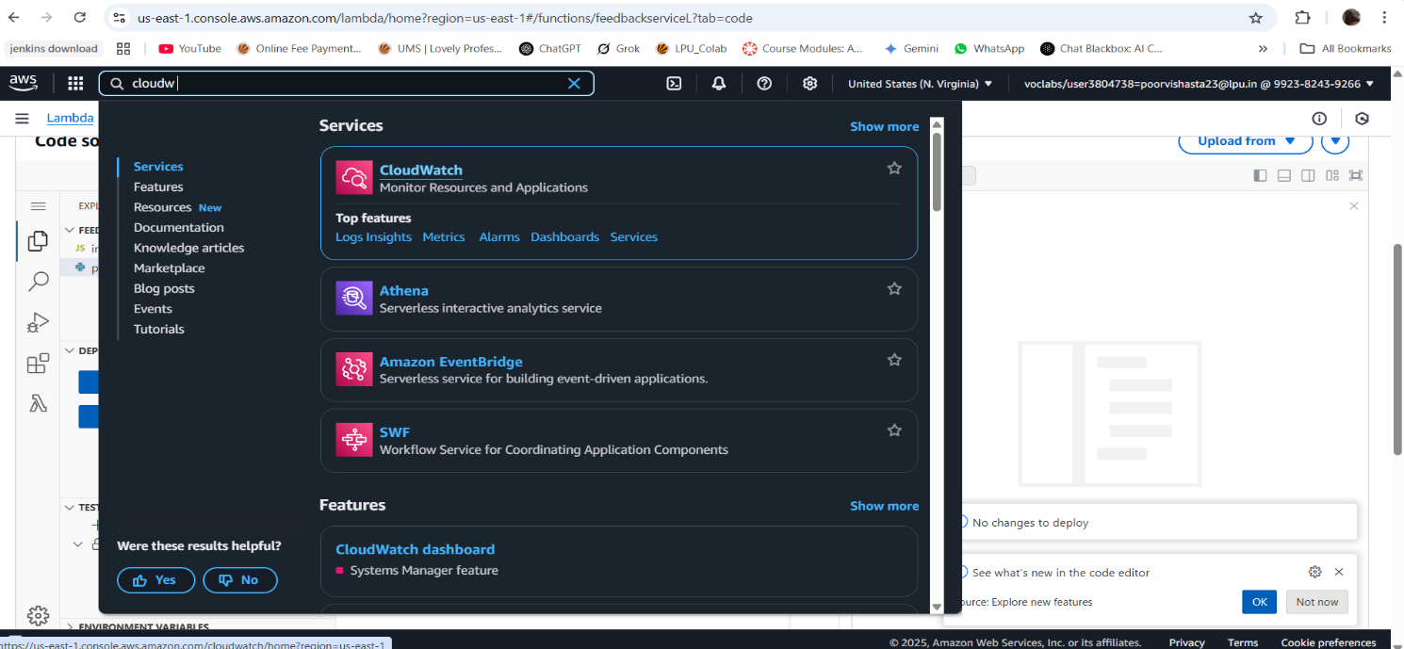
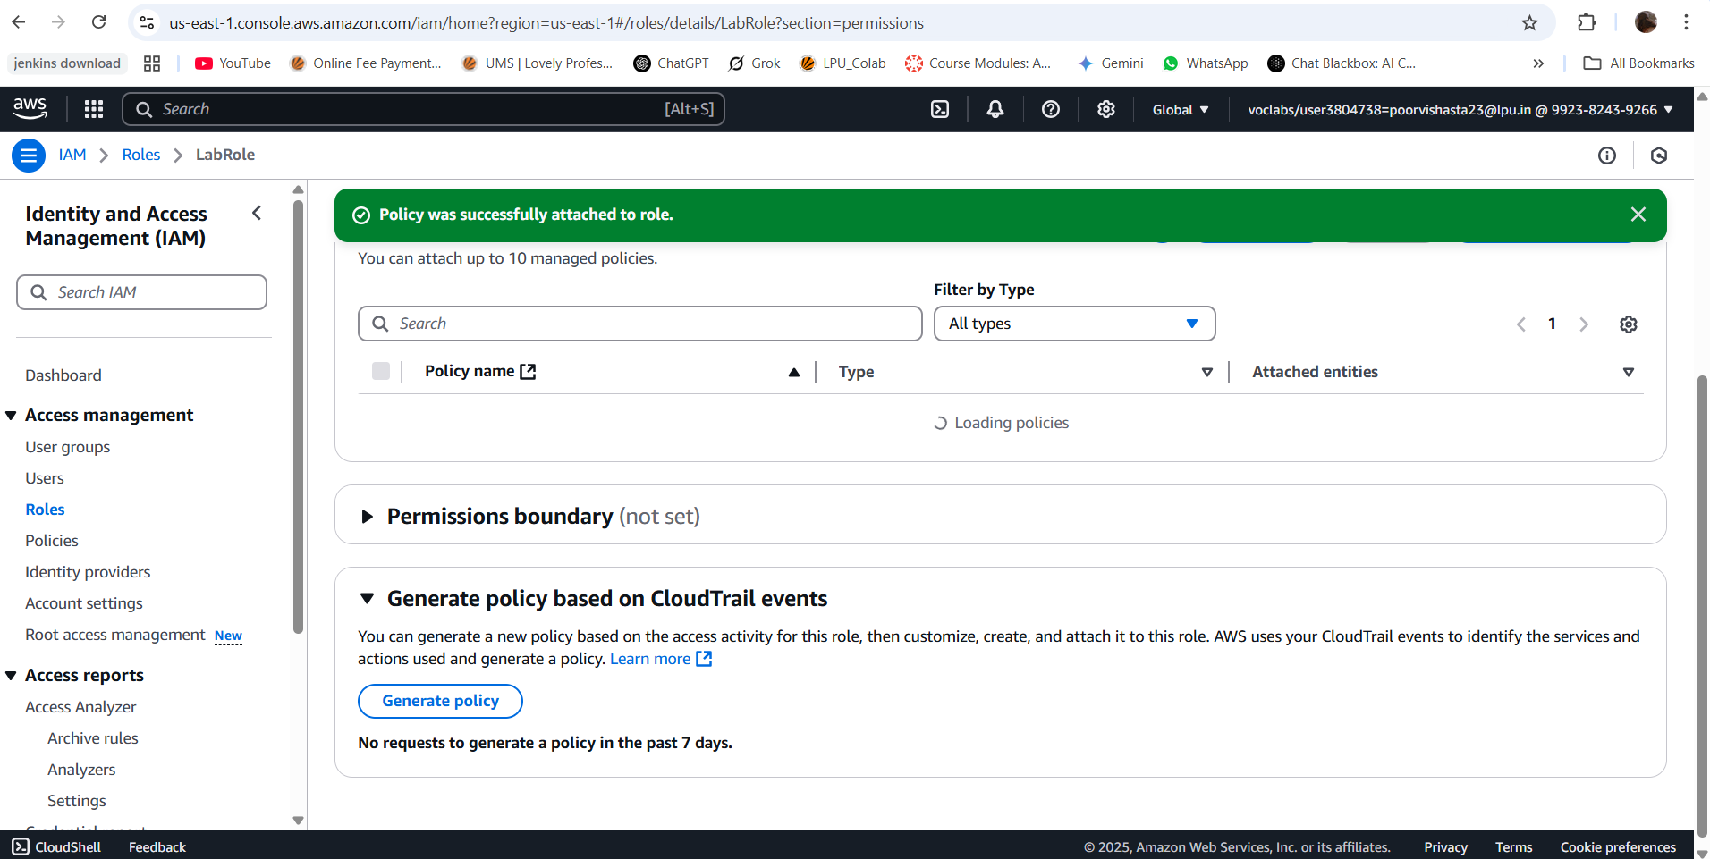
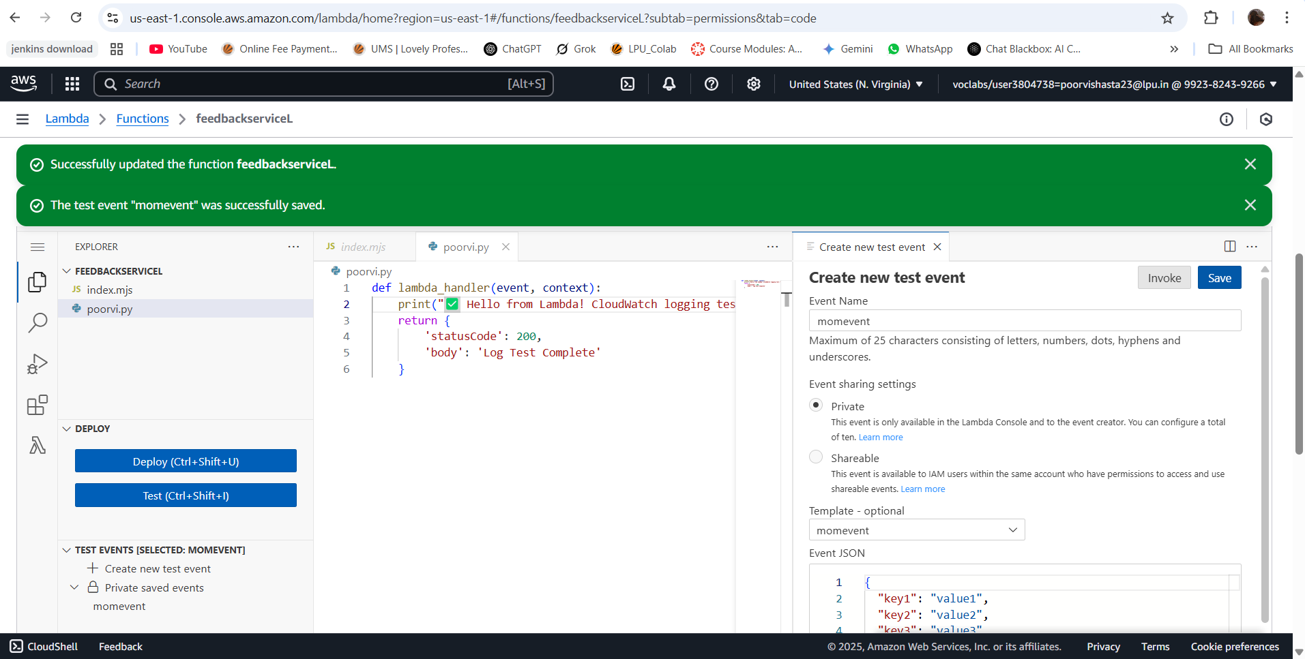
Step 4: Enable CloudWatch Logging
Automatically enabled with Lambda.
Go to CloudWatch > Log groups >

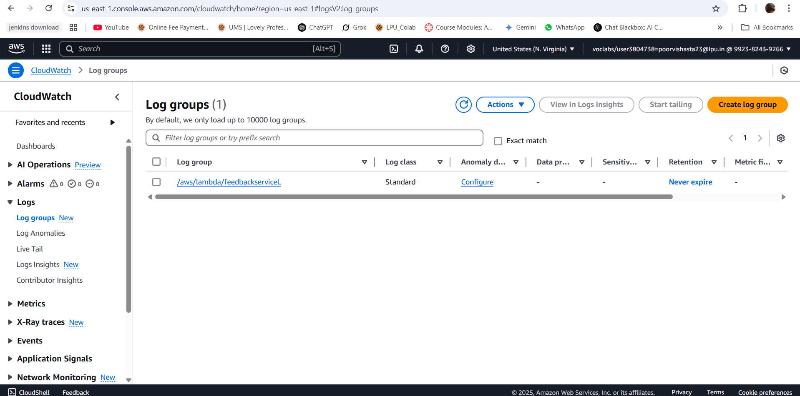

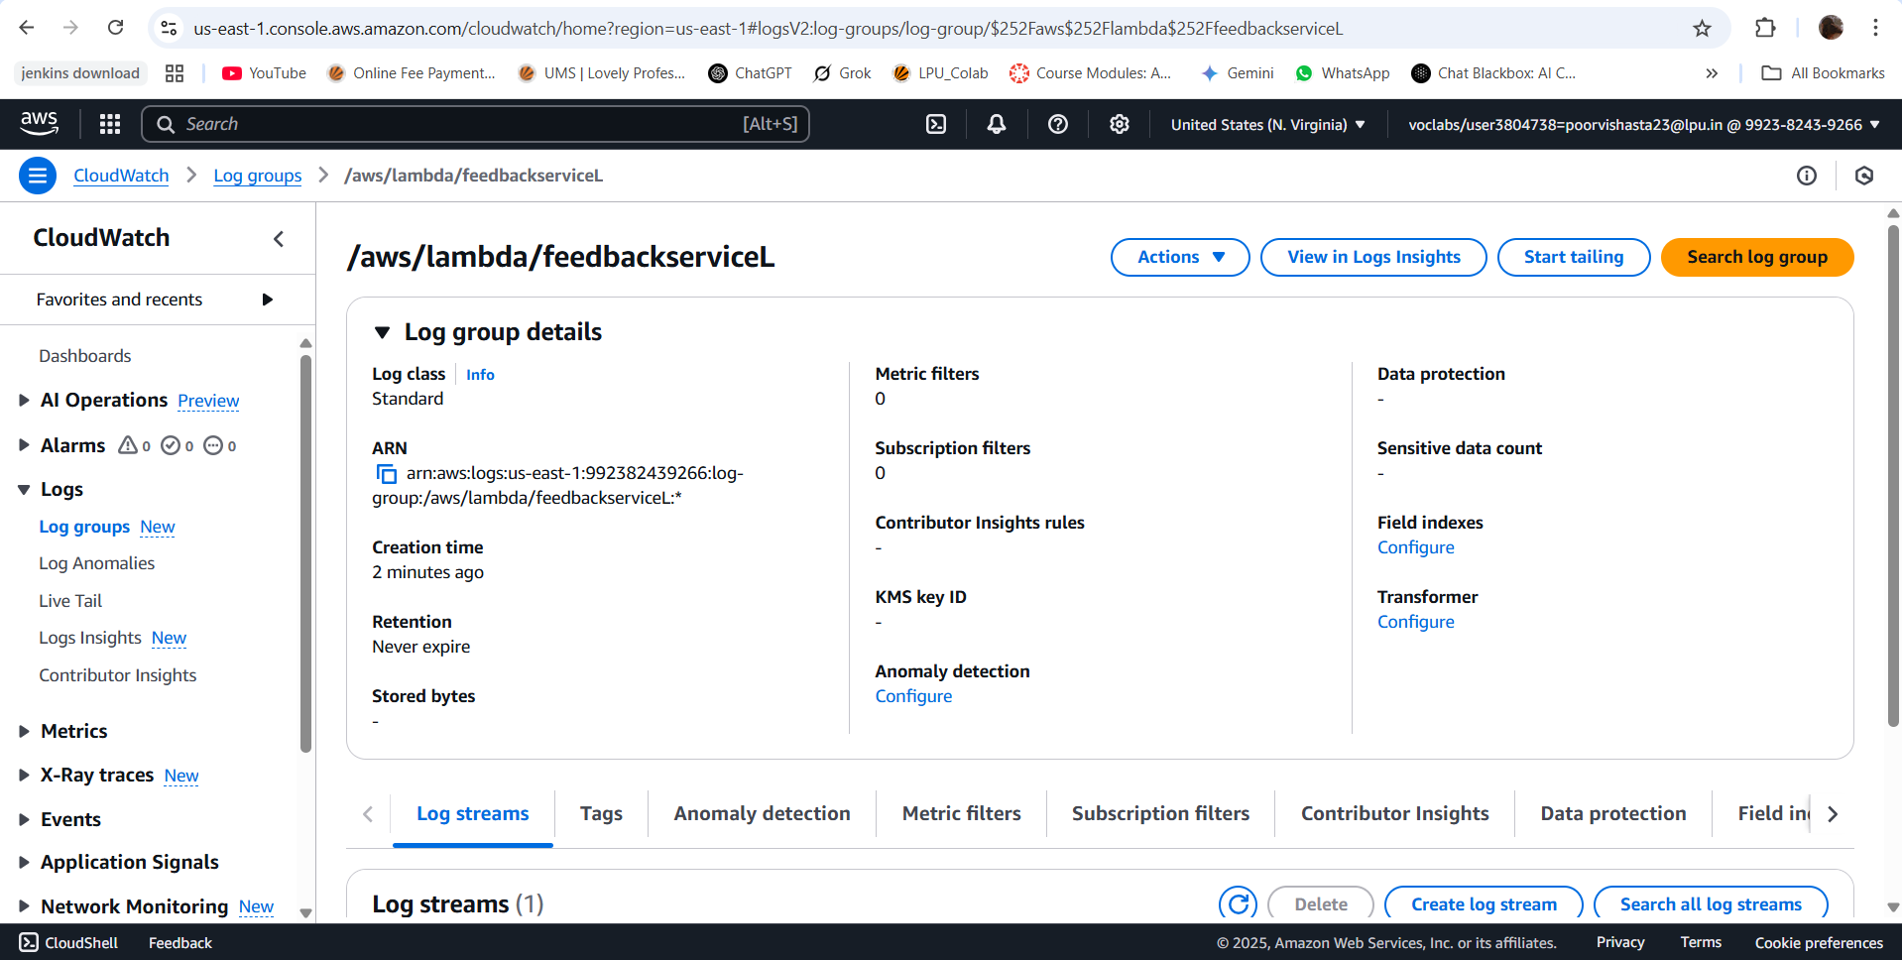

Conclusion: Serverless Feedback Logger using AWS (S3, Lambda & CloudWatch)
In this project, we successfully designed a scalable, secure, and cost-efficient AWS architecture for an e-commerce platform that faces unpredictable traffic spikes during promotional events.
